JOHN BONNER
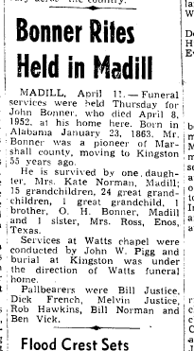

http://o.mfcreative.com/f4/exports/a/a2d6ff5b-4c46-4325-a27c-38809955d4ac/John%20Bonner%20obituary.pdf

THE WHOLE FAMILY 7/2/2013
http://trees.ancestry.com/tree/25877646/person/13684342028

